Font:
Roboto+Condensed
https://fonts.google.com/selection?query=robo&selection.family=Roboto+Condensed
Lato
https://fonts.google.com/selection?selection.family=Lato|Roboto+Condensed&query=lato
Fredoka One
https://fonts.google.com/selection?query=Fredoka&selection.family=Fredoka+One

Footer Section

Part1:
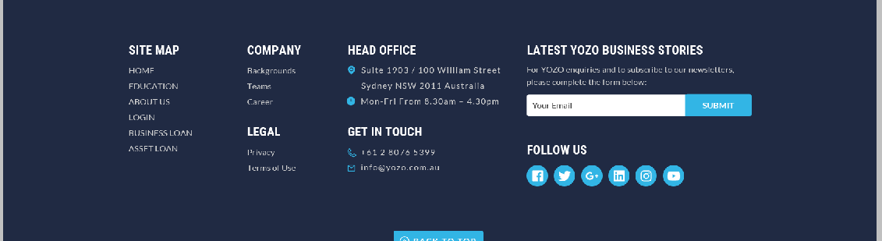
Background color: # 202a43

Button/Icon Color:# 32b5e5

Title Color: white Title font size: 24px Title Font family: Roboto Conden…
Title Font weight: Bold

Content Color: # d0d0d0 Content font size: 16px Content Font family: Lato
Title Font weight: Normal

Part2:
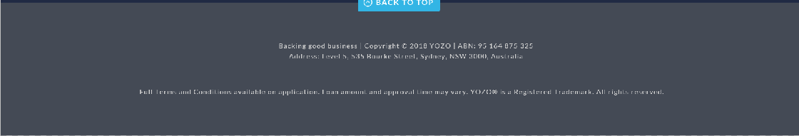
Background color: # 444a55

Content Color: # d0d0d0 Content font size: 14px Content Font family: Lato
Title Font weight: Normal

Need Help Section
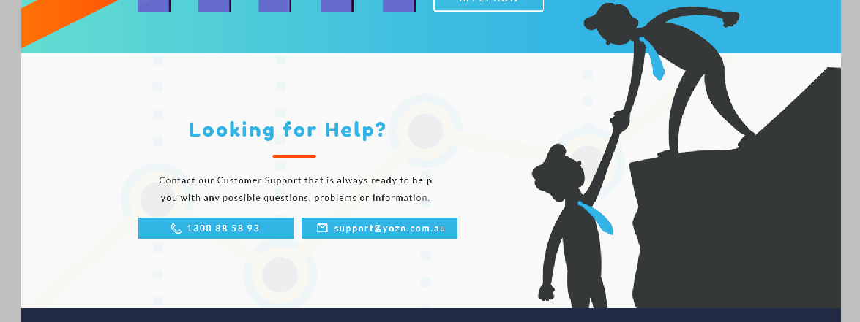
Background image: Section3_Help_bg1.jpg

Image: Section3_Help_bg2.png

Title Color: # 32b5e5 Title font size: 40px Title Font family: Fredoka One
Title Font weight: Bold

Content Color: # 212121 Content font size: 18px Content Font family: Lato
Title Font weight: Normal

<HR> color: # ff4a04

Benifit Section
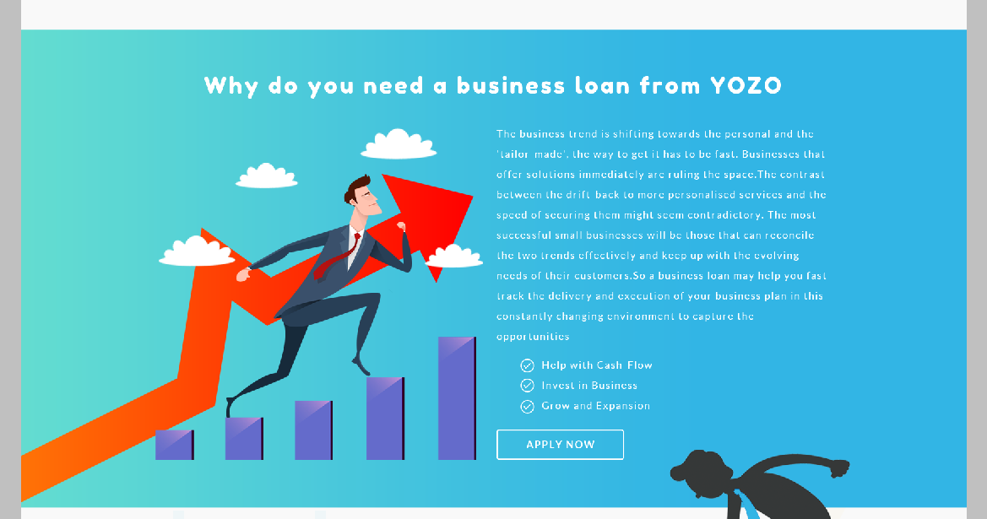
Background image: Section2_Benifit_bg1.jpg

Title Color: white Title font size: 40px Title Font family: Fredoka One
Title Font weight: Bold

Content Color: white Content font size: 18px Content Font family: Lato
Title Font weight: Normal

<HR> color: # ff4a04

